TTI 1906 Multimeter Ballpark DC Calibration Procedure

Before we begin there are a few things to be aware of and a copy of both the user and service manuals will be absolutely necessary and these should be thoroughly read beforehand, the sequence below worked for me after quite a number of trials and errors and the meter I adjusted was initially out of calibration by approximately 2.14% in the dc range, when a stable 10.0000 Vdc was applied the meter would display 10.2143 which made the unit almost unusable for my applications considering that the original manufactures specifications were around 0.019% plus 3 counts in the 20 volt range. The previous owner confirmed that they had used the calibration button and then the store key which will load the original factory constants, this may not be desirable as it returns the meter to a state that may then need to be calibrated, the calibration history may be verified by using the calibration button and log key to show which values have been altered or defaulted.

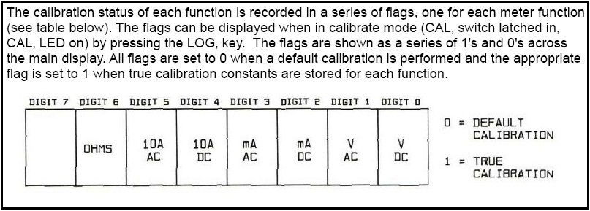

The meter uses nine steps to calibrate the dc range and this must be done before any other modes are calibrated, you will need a variable and preferably a programmable power supply capable of providing a stable output as the meter needs to see a valid and stable voltage before you can store the reference and move on to the next step. You will also need another accurate, reliable and trusted multimeter along with any required test leads to monitor the output from the power supply during the process, the more accurate this meter is the better the final result will be, you will also require a computer running Windows XP with a DB-9 serial port and the cable below.

The first step is to make an RS-232 male to female DB9 cable to connect the meter to the computer, the meter end only uses pins 2,3, and 5, the computer end is straight through on 2,3 and 5 but also links pins 1,4,6 together and pins 7,8 separately as shown in the picture below.

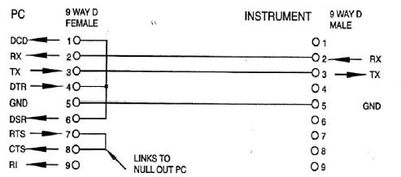

Next configure the communications port on the computer with the settings shown below, note that Xon/ Xoff is stated in the service manual but I could not get it to work reliably so instead used the hardware setting, I used an older laptop running Windows XP and had no success at all with HyperTerminal or any other serial cable except for the one listed above which I made.

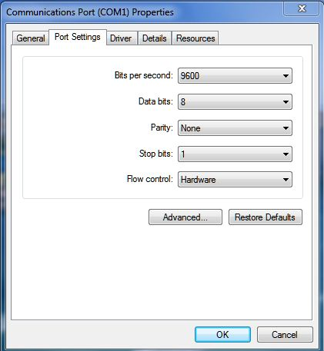

Ensure that the meter has been powered up for at least half an hour beforehand and record a few measurements at various ranges to compare with later then connect the meter to the computer and download and install the TTI Arcwin program on the PC, on the meter press program then baud and set the baud rate to 9600 then press the enter/ auto button, then in a similar manner set the units address by pressing program then address then use the up/ down cursors to select 1, then press the enter/auto button to store the address. If you get a port busy or unavailable message in the Arcwin software then go to device manager and uninstall the port and restart the PC to restore the port.

To verify that communications are established between the meter and the PC in the Arcwin software press the status icon in the left panel and it should display device found with the following address 1, the remote LED on the meter may illuminate and when this is on all of the buttons on the meter are disabled so to restore local operation send an X to the meter from the PC then press the remote button on the meter, so a capital X then enter and the remote button.

Connect the dc power supply to the meter and select Vdc and leave it in the auto-range mode
then to test if the meter is receiving commands type 1 RANGE 3 and then press the enter key to send the command and the meter should then change range, next send an X to the meter from the PC and once again press the meters remote button to restore the local buttons. I found that if communications were left on for a long duration the meter would eventually hang and require a power restart to restore, so use the X command frequently and perform operations on the meter in local mode as often as possible during the entire process.

Using a short length of 4.0 mm electrical cable and two good quality banana plugs I made up a link strap that will be required for the first three steps, be sure to verify the integrity and low resistance of this strap on your other meter before proceeding any further. With the shorting link connected between the common and input terminals depress the calibration switch on the meter then select the dc mode and wait for the “c” to blink continuously in the display then press the up cursor to store that value and move to the next step, if the display shows an “F” then the reading failed and was unstable at the time you pressed the up cursor button so press the dc button and start over. Skipping to the next step after an “F” will result in a “nocal” state at the end of the entire process so you are advised to wait for the continuous flashing “c’ before pressing the up cursor and storing the reading. At any point the calibrate switch can be released and the unit will resume normal operation with the previous reference values loaded.

The first three steps are relatively straight forward as they are just a dead short across the input, once these steps are done the meter will display +200.000 so remove the link strap and apply a stable 200 millivolts to the input and observe the correct polarity whilst monitoring the applied voltage on your other meter to ensure it is accuracy and stability, if the reading is valid the display will again have a blinking “c” so press the up cursor as done in the previous steps. Next will be the +2.00000 or 2 volt range so apply the correct voltage and the same as before wait for the blinking “c” then press the up cursor, if passed the meter will go to the next step and show -2.00000 this now requires that the input leads be reversed as the meter is expecting minus 2 volts and after this step be sure to reverse the leads back to the correct polarity ready for the next step of +20.0000 followed by +200.000 then +1000.00.

Now here comes the tricky bit, I did not have the ability or equipment to generate either of the final two values of 200 and 1000 volts dc and was not having any luck competing the procedure and initially considered purchasing a large quantity of A 23 batteries and putting 16 of them in series inside lengths of electrical conduit to make up a number of 200 volt modules, one module for the 200 volt range and five modules in series for the 1000 volt range, a total of eighty batteries which I would probably never use or need again.

This was not only going to be a costly exercise but also probably rather dangerous and with the required effort involved not much less than it would cost to get the meter properly calibrated and adjusted by a lab which I did price at around $420 AUD, I did find A 23 batteries for around $1 each in quantity so eighty bucks all up just for the dc range, ac and resistance are a whole other matter which again I don’t have the required equipment to adjust these parameters.
This was a dilemma as I did not want to spend that type of money on this meter, I paid bugger all for it and did not know at this point if I would even use it for general measurements, if it was a quality product such as a Fluke, Keysight or Keithley then I wouldn’t hesitate in getting it properly verified and adjusted but this meter at this time did not warrant any further outlay.

To overcome this problem of performing the last two steps of the calibration process the service manual declares that the auto/ enter button can be used to skip a step and then use the existing pre-loaded values, unfortunately this was not the case and the auto/ enter key did nothing at all and neither did the AUTO or STEPCAL remote commands via the PC software, one instruction that did work and came to the rescue was the SETCAL command using the software which permits the required value to be altered so once the display showed +200.000 in relation to the application of two hundred volts I simply typed 1 SETCAL 020000 enter then X enter on the PC and this now told the meter to expect +20.0000 volts which was already provided from the previous step. I then waited for the blinking “c” on the meter and stored the reading with the up cursor and used the same procedure with the +1000.00 volt range by typing 1 SETCAL 002000 enter followed by X then enter as six digits are required in all steps, once this was done the meter displayed CAL donE so I then pressed the store button followed by the release of the calibration switch on the meter to return to normal and reasonably accurate operation.

